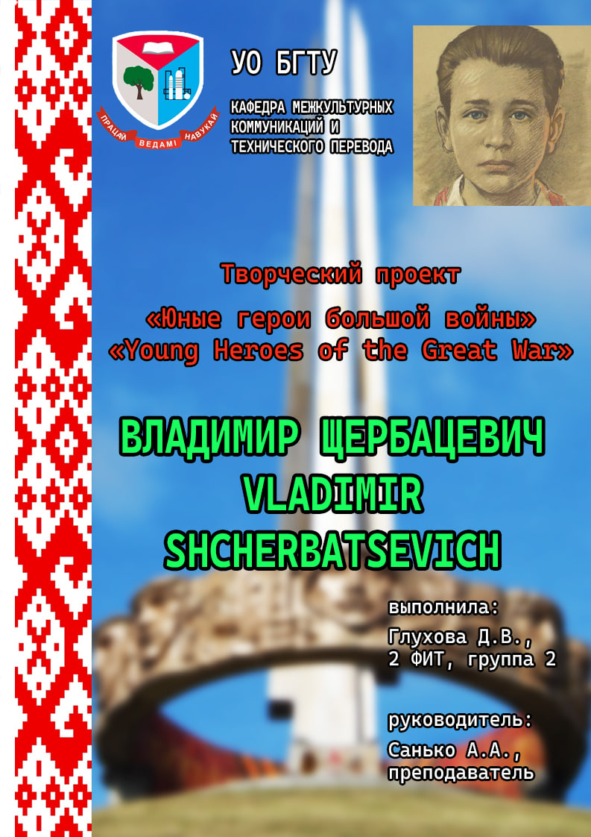

**Vladimir Ivanovich Shcherbatsevich**

Date of birth: December 31, 1926

Date of death: October 26, 1941 (age 14)

Place of death: Minsk, General District of Belarus, Reichskommissariat Ostland

Country: USSR

Occupation: student, underground worker

War… How much terrible and heavy this word carries. How many cities she destroyed, how many villages and villages she wiped off the face of the earth. Millions of people during the Great Patriotic War voluntarily went to the front and shed their blood for the sake of the future of their Homeland, family and children. The war deprived many children of childhood, all of them had to learn the hardships and hardships of war from an early age. Most of the pioneers worked in the rear – in factories, factories and industries, standing at the machine tools instead of brothers and fathers who went to the front. But there are also cases when teenagers themselves, forgetting about danger and fear, went to war on an equal basis with adults, participated in combat operations and intelligence operations.

The war has a childish face – everyone knows that. But how many people know how many times they crossed paths.

Young heroes, these are children like you. They fought for world peace. So that people do not die from bandits, terrorists, so that there is no fascism on Earth. The alarm call sounded the words "Get up, the country is huge!" in the early days of the Great Patriotic War, when the Nazi hordes treacherously invaded our land. The entire Soviet people rose up in the holy struggle against the Nazi invaders. Together with their fathers, older brothers and sisters, thousands of young patriots who fought against fascism went into battle with weapons in their hands.

Many young heroes died for the freedom of our Motherland. The glorious military deeds of the young heroes will forever remain in the grateful memory of the people. Those who courageously fought with the fierce enemy on the battlefields of front-line battles, in partisan detachments and in underground conditions. Those who contributed to the coming victory and to whom today's peers owe a happy peaceful life.

Hundreds of schoolchildren fought in partisan detachments and were members of underground organizations. They were scouts and signalmen, sisters of mercy and subversives.

Among them are the pioneers-heroes Valya Kotik, Marat Kazei, Zina Portnova, Lenya Golikov. Before the war, they were just ordinary boys and girls. We studied, helped the elders, played, ran, jumped, broke noses and knees. Only relatives, classmates and friends knew their names. The boys. Girls.

The weight of the hardships, disasters, and grief of the war years fell on their fragile shoulders. And they did not bend under this weight, they became stronger in spirit, more courageous, more enduring. Little heroes of the great war. They fought alongside their elders - fathers, brothers, communists and Komsomol members. They fought everywhere. At sea, like Borya Kuleshin. In the sky, like Arkasha Kamanin. In a partisan detachment, like Lenya Golikov. In the Brest fortress, like Valya Zenkina. In the Kerch catacombs, like Volodya Dubinin. Underground, like Volodya Shcherbatsevich. And the young hearts did not tremble for a moment! Their matured childhood was filled with such trials that even a very talented writer would have found it hard to believe. But it was. It happened in the history of our big country, it happened in the destinies of its little guys - ordinary boys and girls.

Before the war, they were just ordinary boys and girls. We studied, helped the elders, played, ran, jumped, broke noses and knees. Only relatives, classmates and friends knew their names.

The hour has come - they have shown how huge a small child's heart can become when sacred love for the Motherland and hatred for its enemies flare up in it.

The boys. Girls. The weight of the hardships, disasters, and grief of the war years fell on their fragile shoulders. And they did not bend under this weight, they became stronger in spirit, more courageous, more enduring.

Little heroes of the great war. They fought alongside their elders - fathers, brothers, communists and Komsomol members.

They fought everywhere. At sea, like Volodya Shcherbatsevich.

Volodya Shcherbatsevich is the first young hero who gave his life for his Homeland during the Great Patriotic War.

Vladimir Shcherbatsevich was born in 1926 in a military family. Volodya lived in Minsk. His father died in the Finnish War. Together with his mother Olga Fedorovna Shcherbatsevich, they lived in Minsk on Kommunisticheskaya Street.

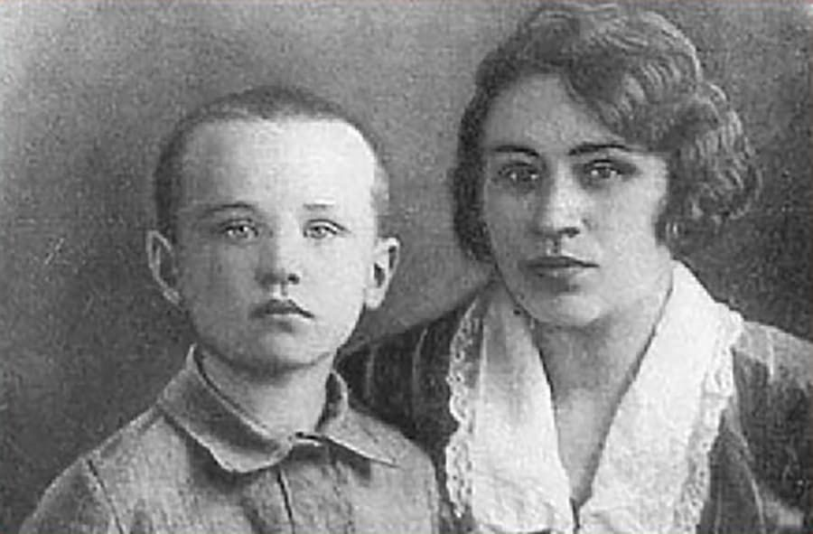 Olga Fedorovna worked at the 3rd city hospital, and Volodya studied at secondary school No. 6 in Minsk. Mom was a doctor. When the fascists came, they nursed the wounded soldiers and transported them to the partisans.

On June 28, Wehrmacht units entered the city, and the period of occupation of Minsk began. Shcherbatsevichi did not accept the new rules. An underground group was created to rescue commanders and political workers of the Red Army who were in the hospital, headed by a worker from the Minsk Wagon Repair Plant named after him. Myasnikova K. I. Trusov and cultural worker of the 3rd city hospital O. F. Shcherbatsevich.

Some of the prisoners of war who were able to be taken out of the hospital, it was decided to transport several groups across the front line. In one of these groups (together with O. F. Shcherbatsevich and her son Volodya Shcherbatsevich) there was a former prisoner of war Boris Rudzianko. Having arbitrarily separated from his group, he returned to Minsk, where he was detained by the Germans and, during interrogation, betrayed members of the underground.

From the first days of the occupation of the city of Minsk, the Shcherbatsevichi mother and son hid Soviet commanders in their apartment, to whom the underground workers from time to time arranged escapes from the prisoner of war camp.

Volodya was wounded several times.

Olga Fyodorovna, that was the name of Volodya's mother, provided first aid to those who fled, dressed them in civilian clothes, which she collected from relatives and acquaintances.

Once, according to forged documents, they took out a whole truck with military prisoners to the partisans. The release of prisoners of war was the main task for everyone.

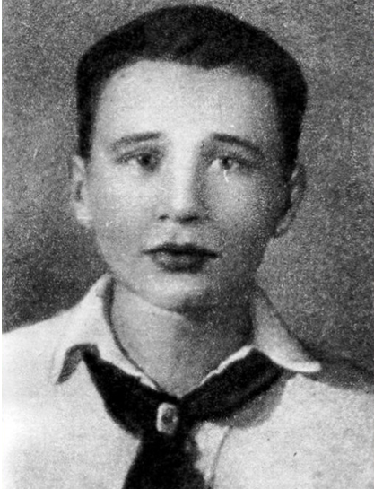

Olga Shcherbatsevich not only nursed the prisoners in the hospital, but also sheltered them later at home or with her two brothers and sister. Her son Volodya helped his mother get civilian clothes for the fugitives, and then took them out of the city. One day they got the uniforms of German soldiers, dressed the prisoners in them, and Olga's brother took them out of town.

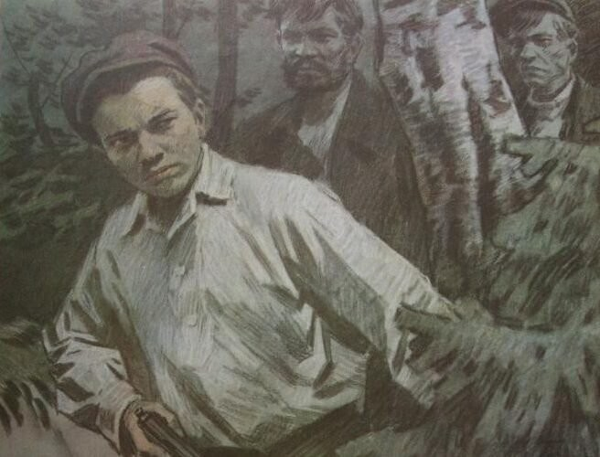 Hospital orderly Leonid Zorin, Peter and Nadezhda Yanushkevich sheltered the fugitives at home. Paramedic Pisarenko provided the rescued with documents and took them out of the hospital. The dressmaker Elena Ostrovskaya helped with clothes. Sonya Idelson, as a student at the medical institute, treated prisoners of war with medicines from her father's stocks, made by him before the arrival of the Germans. Her friend Masha Bruskina, a graduate of the Minsk School, also worked with Sonya. It was she who managed to get and transfer to the hospital a camera, for not handing over and storing which was supposed to be shot! With the help of a camera, a photograph was taken for the documents that the prisoners of war were supplied with before escaping.

In September, raids suddenly began, and many more wounded who escaped from captivity were hiding in the houses of Minsk residents… Their friend betrayed them, he was a traitor. Volodya was arrested by policemen. ...Interrogations, torture. My whole body aches, I'm shivering, I don't have the strength to get up from the cold stone floor. But he didn't tell the fascists anything.

On October 26, 1941, twelve underground workers were executed in Minsk, hanged in groups of three in different places of the city for "making false passports and involvement in the partisan center located in the infirmary for Russian prisoners of 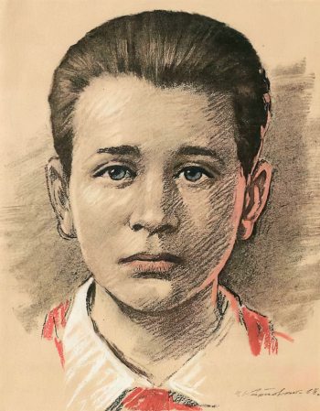war."

Volodya (Vladlen) Shcherbatsevich, along with his comrades in the underground, Kirill Coward (Trusov) and Masha Bruskina, was hanged on the arch of the gate of the yeast factory on Voroshilov Street (since 1961 — Oktyabrskaya Street). His mother Olga Shcherbatsevich was executed on the same day in another place in the city. Nadezhda Yanushkevich and Pyotr Shcherbatsevich (Olga Shcherbatsevich's sister and brother), Nikolai Kuznetsov (Nadezhda Yanushkevich's husband), Elena Ostrovskaya (Olga Shcherbatsevich's roommate) were also hanged. The execution was carried out by the punishers of the 2nd Lithuanian battalion of the auxiliary police Service under the command of Major Antanas Impulavicius and filmed by a photographer from Kaunas.

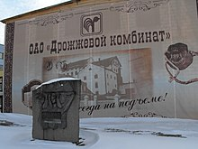

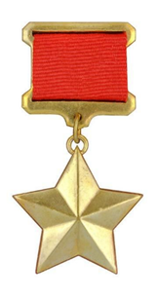 In 1976, he was awarded the title of Hero of the Soviet Union posthumously.

In 1967, the documentary "Executed in '41" was shot - about the investigation by journalist and children's writer V. N. Morozov to identify Volodya Shcherbatsevich in a famous photo from the place of execution.

Later, V. N. Morozov, as a children's writer, wrote several works about Volodya. For the first time, the story "Volodya Shcherbatsevich" was published in 1969 and released by the publishing house "Malysh". In 1974, the story was included in the book (collection of short stories) "Arkasha Kamanin, Albert Kupsha, Marx Krotov, Kolya Ryzhov, Volodya Shcherbatsevich".

This edition was intended for young children, and for adults V. N. Morozov published the story "Volodin Front: A documentary story about the pioneer hero V. Shcherbatsevich", published in Moscow by the publishing house Molodaya Gvardiya in 1975.

In 2023, a school in the hero city of Minsk - GUO Secondary School No. 9 named after V.I. Shcherbatsevich Minsk was named in honor of Vladimir Ivanovich Shcherbatsevich.

The fascists did not feel like masters in Minsk for a single day. Among the fighters of this front was Volodya Shcherbatsevich, a Minsk pioneer. Shortly before his execution on August 16, 1941, the newspaper Pravda wrote: "Our children are heroic, magnificent Soviet children, now fighting for their Homeland with the courage of adults, with the intelligence of adults. And their struggle is the most convincing documentation of our truth. Their struggle is the most terrible accusation that history will ever bring against a vile enemy, studying the events of our days." To this day, the Minsk boy who ascended the scaffold accuses the instigators of the war.